* What is your prototype about?
* What will people learn from your experience?
* Will it be interactive or is it something people will watch?
* If interactive, what can the user do?
* How would your design fit in with the Exploratorium?
* Draw a diagram that explains how your prototype works.
* Are there any existing systems that are similar to yours? Name and link them.

Also include descriptions of the:

* Easy Version **This**
* Clever Version **Actually program A.I and make it so that the computer misses 5% of the time or something**
* Advanced Version **Add different types of shot selections to the game and each shot will have a different chance of making it all the way to the opponent. For instance doing a slice at the wrong time may yield a 50% chance of missing, whereas a forehand may be successful 95% of the time during a certain shot.**

My prototype for my Final Project proposal will be based off of a little bit of both collision detection and game design. My general idea will be to create a tennis game based off of the mechanics of “pong”. I will use collision to make the ball collide and bounce back whenever it hits the tennis racquet. With this experience that I will create, people will learn all about the basics of collision detection and game design and see firsthand how it can be easily used and implemented to create simple games, and how these techniques can be used as the basis for almost all large scale games. This will be an interactive experience, which will initially only be one-player, but can easily be modified to also add a two-player co-op experience.

[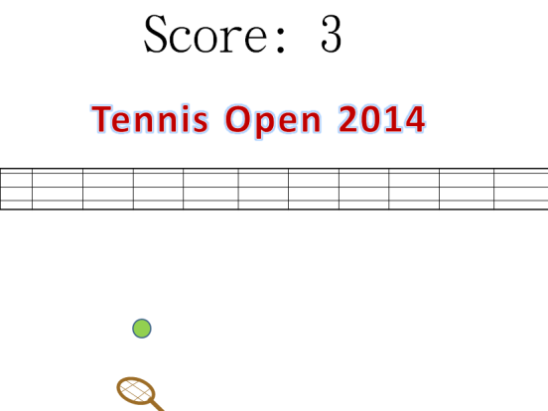](https://rahuladityamani.files.wordpress.com/2014/07/finalprojectprototype.png)

To be implemented into the Exploratorium, which I talked about in my previous blog post, the game could be modified to test various aspects of the 5 senses. For example, the Exploratorium had an exhibit in which a user had to play pong by listening to beeps in headphones. If the beep played on the left, the user knew that the ball could be coming to the left. The same concept could also easily be applied to the other human senses as well.

